# INTRODUCTION

* 1. **SYSTEM DEFINITION**

# The Photography Management System (PMS) is a web-based software solution designed to streamline and automate the core operations of photography businesses. It offers a centralized platform that integrates all essential functions needed to manage client relationships, bookings, payments, photo storage, and delivery workflows. This system reduces the burden of manual tasks and ensures smooth communication between photographers and clients, ultimately improving service quality and business efficiency.

# PROJECT DESCRIPTION

The Photography Management System (PMS) is a comprehensive web-based application tailored to the needs of photographers and photography studios. As the demand for professional photography services grows, photographers face increasing administrative burdens alongside their creative tasks. PMS seeks to alleviate these challenges by centralizing and automating key operational aspects such as client management, bookings, payment tracking, photo storage, and delivery.

With PMS, photographers can manage client relationships more effectively. The system offers functionalities like client tracking, automated appointment reminders, and digital contracts, which enhance customer satisfaction by providing a seamless experience from booking to delivery. This feature-rich environment caters not only to independent photographers but also to photography studios managing multiple clients, staff, and sessions, making it an ideal tool for teams of all sizes.

In addition to client management, PMS simplifies the booking process, offering a user-friendly booking interface for clients and staff alike. This booking module allows clients to view available slots, select services, and schedule appointments effortlessly. Photographers can also streamline their scheduling, optimizing time and resources, and ensuring each shoot runs smoothly and on schedule. Moreover, the integrated payment tracking system securely processes transactions, helping photographers manage income, invoicing, and expenses. By tracking payments in real-time, the system reduces errors and minimizes time spent on financial reconciliation.

Photo storage and delivery are another cornerstone of PMS. Through a secure digital platform, photographers can store and organize photos, allowing for easy retrieval and protected client access. This enables photographers to categorize images based on event type, date, or client, reducing time spent searching for files. Clients, in turn, receive their photos promptly through a secure link, facilitating smooth, professional photo delivery that enhances their overall experience.

A powerful addition to PMS is its potential integration with machine learning models for photo filtering. Using a model like FaceNet128dClient or similar technology, PMS can identify and group faces, enabling photographers to sort photos by individuals automatically. This feature is particularly useful for event photographers handling hundreds of images, as it eliminates the need for manual sorting, enhancing efficiency. The machine learning model can further classify images by genre, lighting, and quality, helping photographers select and edit the best shots faster and more accurately.

The adaptability of PMS makes it suitable across various photography fields, such as weddings, portraits, commercial shoots, and events. Its scalability supports the needs of both freelance photographers and large studios, providing a solution that grows alongside their business. By focusing on streamlining operations and improving workflow efficiency, PMS ultimately enables photographers to focus more on their artistic vision and creative goals. Through features like secure storage, payment processing, client management, and machine learning-powered photo filtering, PMS delivers a complete, modern solution tailored to today’s professional photographers.

# MODULES IN THE SOFTWARE

**USER MANAGEMENT:** Allows photographers, clients, and admins to create accounts with role-based access, ensuring secure and appropriate permissions.

**Key functions:**

* Manages user registration, login, and profiles.
* Role-based access control for Admin, Photographer, and Client.
* Ensures secure login with features like password recovery and two-factor authentication.

**BOOKING MODULE:** Provides an interactive calendar for clients to view availability, book appointments, and manage schedules, reducing conflicts and misunderstandings.

***Key functions:***

* Handles client bookings and displays real-time availability using an interactive calendar.
* Allows booking, rescheduling, and cancellations.
* Sends automated notifications and reminders to avoid scheduling conflicts.

**CLIENT RELATIONSHIP MANAGEMENT (CRM) MODULE:** Centralizes client information, preferences, and history, enabling personalized communication and service.

***Key functions*:**

* Stores client data, preferences, and history to offer personalized services.
* Manages inquiries, feedback, and follow-ups.
* Helps build customer loyalty through targeted communication and offers.

# SYSTEM STUDY

* 1. **EXISTING SYSTEM**

In most photography businesses, many processes are still handled manually or with separate tools that are not fully integrated, leading to operational inefficiencies. Traditional approaches to managing bookings, payments, client communications, and photo delivery often rely on multiple platforms like spreadsheets, emails, social media, or third-party cloud storage. While these methods can work for small-scale operations, they become cumbersome as the business grows. Below are the key aspects of the existing systems typically used by photographers and their limitations.

An existing photography management system (PMS) typically includes several features designed to streamline operations for photographers and studios. It offers a client management system where client details, booking history, and preferences are stored, along with integrated CRM tools to track communication and send reminders or promotions.

The booking and scheduling feature allows clients to book appointments online, with integration to a calendar that ensures no double bookings and sends automated reminders to both clients and photographers. For payment management, the system integrates online payment gateways, generates invoices, and tracks payments and overdue balances.

Photo storage and delivery is made easier with cloud storage for secure image storage, client-facing galleries for photo viewing and downloading, and possible integration with photo editing software. The photo management section includes features for tagging, categorizing, and sorting images, along with tools for filtering and sorting based on quality or content, as well as handling metadata like camera settings.

Reporting and analytics tools help generate financial reports on income and expenses, and client insights are available to analyze booking patterns and preferences. The system may also include marketing and engagement features like email campaigns, social media integration, and loyalty programs to help retain and attract clients. Lastly, collaboration tools allow team members to access and manage bookings, photos, and tasks, enabling efficient teamwork within the studio.

Disadvantages of Existing System

1. Lack of Centralization.
2. Inadequate manpower.
3. Requires a lot of space to work.
4. Fragmented Payment Tracking.

## PROPOSED SYSTEM

The **Proposed Photography Management System (PMS)** aims to overcome the limitations of the existing system by integrating key business processes into a single, efficient platform. It automates and streamlines operations such as bookings, payments, photo storage, delivery, and client management, offering an improved user experience for photographers and clients alike. With a focus on security, scalability, and ease of use, the proposed system enhances business productivity and customer satisfaction.

The **Proposed Photography Management System (PMS)** is designed to address the inefficiencies, challenges, and limitations faced by photography businesses using traditional methods. The proposed system centralizes operations, automates essential tasks, ensures security, and enhances customer service, providing a seamless experience for both photographers and clients. Through the integration of multiple modules—like booking, payment, client relationship management (CRM), cloud storage, and analytics—this system transforms the way photography businesses operate, making them more efficient, scalable, and competitive in the digital age.

Below is a detailed overview of the system, its components, features, and benefits.

# Advantages of Proposed System

* + Customer satisfaction.
  + Appointment booking
  + Improved Customer Experience
  + Admin can consider the bare minimum of job functionality.
  + Digitization saves time and helps to make the most of resources.
  + Overall cost reduction
  + Data accuracy
  + Data security

# DATA FLOW DIAGRAM

The Data Flow Diagrams (DFDs) are used for structure analysis and design. DFDs show the flow of data from external entities into the system. DFDs also show how the data moves and are transformed from one process to another, as well as its logical storage. The following symbols are used within DFDs.

A data flow diagram (DFD) is a graphical representation of the flow of data through an information system, modelling its process aspects. A DFD is often used as a preliminary step to create an overview of the system, which can later be elaborated. DFDs can also be used for the visualization of data processing (structured design).

A DFD shows what kind of information will be input to and output from the system, where the data will come from and go to, and where the data will be stored. It does not show information about the timing of process or information about whether processes will operate in sequence or in parallel.

Here’s a description of the key components and content you would include in a DFD, written as sentences:

1. **External Entities**: External entities are the sources or destinations of data that interact with the system. These can be users, other systems, or any external component that sends or receives data. For example, in a Photography Management System, external entities might include the photographer, clients, and third-party payment gateways.

# Processes: Processes describe the operations or actions that take place within the system, transforming incoming data into outputs. Each process performs a specific function, such as managing bookings or processing payments. These processes are represented as circles or rounded rectangles in the DFD.

# Data Stores: Data stores represent locations where data is held or stored within the system, such as a database or file storage. These stores hold information needed for processes to function, like client records or photo storage. They are represented by open-ended rectangles in the DFD.

# Data Flows: Data flows indicate how information moves between processes, data stores, and external entities. These are shown as arrows in the diagram, with labels that describe the type of data being transferred, such as "Client Information," "Payment Details," or "Booking Requests."

# Leveling: DFDs often use different levels to represent increasing detail. The Context Diagram (Level 0) shows the system as a single process with interactions with external entities. Level 1 and Deeper Diagrams decompose these high-level processes into smaller, more detailed sub-processes, showing a deeper breakdown of the system's operations.

# PHYSICAL VS LOGICAL DFD

A logical DFD captures the data flows that are necessary for a system to operate. It describes the processes that are undertaken, the data required and produced by each process, and the stores needed to hold the data. On the other hand, a physical DFD shows how the system is implemented, either at the moment (Current Physical DFD), or how the designer intends it to be in the future (Required Physical DFD).

Thus, a Physical DFD may be used to describe the set of data items that appear on each piece of paper that move around an office, and the fact that a particular set of pieces of paper are stored together in a filing cabinet. It is quite possible that a Physical DFD will include references to data that are duplicated, or redundant, and that the data stores, if implemented as a set of database tables, would constitute an un-normalized (or de-normalized) relational database. In contrast, a Logical DFD attempts to capture the data flow aspects of a system in a form that has neither redundancy nor duplication.

# DATA FLOW SYMBOLS AND THEIR MEANINGS:

**Entity:** A source of data or a destination for data.

**Source/Sink:** Represented by rectangles in the diagram. Sources and Sinks are external entities which are sources or destinations of data, respectively.

Process: Represented by circles in the diagram. Processes are responsible for manipulating the data. They take data as input and output an altered version of the data.

**Data Store:** Represented by a segmented rectangle with an open end on the right. Data Stores are both electronic and physical locations of data. Examples include databases, directories, files, and even filing cabinets and stacks of paper

**Data Flow:** Represented by a unidirectional arrow. Data Flows show how data is moved through the System. Data Flows are labelled with a description of the data that is being passed through it.

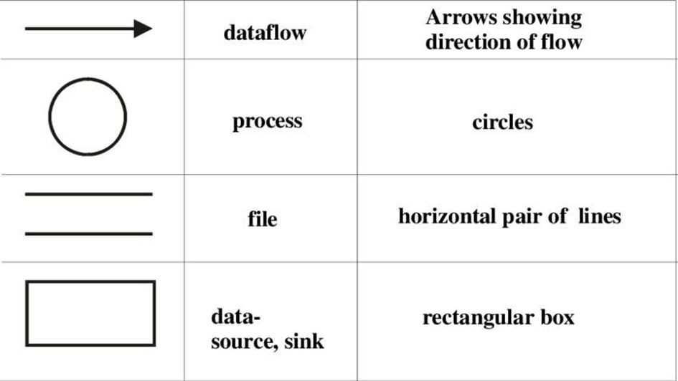

# DFD LEVEL-0

A level-0 DFD is the most basic form of DFD. It aims to show how the entire system works immediately. There is only one process in the system and all the data flows either into or out of this process. Level-0 DFD’s demonstrates the interactions between the process and external entities. They do not contain Data Stores.

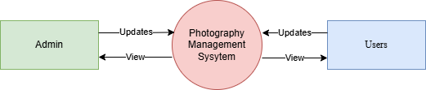

# DFD LEVEL 1

Level 1 DFD’s aim is to give an overview of the full system. They look at the system in more detail. Major processes are broken down into sub-processes. Level 1 DFD’s also identifies data stores that are used by the major processes. When constructing a Level 1 DFD, we must start by examining the Context Level DFD. We must break up the single process into its sub-processes and then pick out the data stores from the text we are given and include them in our DFD. Like the Context Level DFD’s, all entities, data stores and processes must be labelled. We must also state any assumptions made from the text.

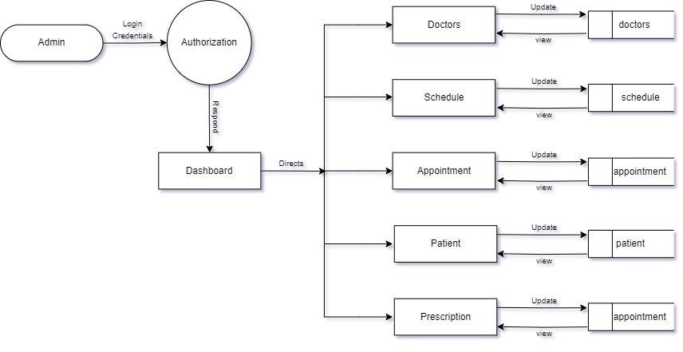

Payment

Payment

Client

Client

# Level 2 DFD:

This level provides an even more detailed view of the system by breaking down the sub-processes identified in the level 1 DFD into further sub- processes. Each sub-process is depicted as a separate process on the level 2 DFD. The data flows and data stores associated with each sub-process are also shown.

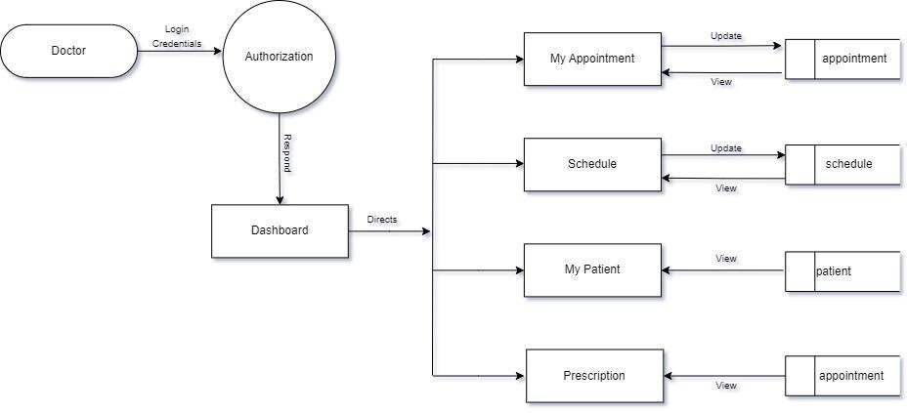

Update

payment

Receipt

payment

Payment

User

# ER DIAGRAM

An entity –relationship diagram (ERD) is data modelling technique that graphically illustrates an information system’s entities and the relationships between those entities. An ERD is a conceptual and representational model of data used to represent the entity framework infrastructure.

# The History of Entity Relationship Diagrams

Peter Chen developed ERD in 1976. Since then Charles Bachman and James Martin have added some slight refinements to the basic ERD principles.

# There are five main components of an ERD:

* + **Entities**, which are represented by rectangles. An entity is an object or concept about which you want to store information.

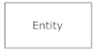

* + **Weak entity** is an entity that must defined by a foreign key relationship with another entity as it cannot be uniquely identified by its own attributes alone.

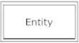

* + **Actions**, which are represented by diamond shapes, show how two entities share information in the database. In some cases, entities can be self-linked. For example, employees can supervise another employee.

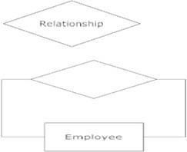

* **Attributes**, which are represented by ovals. A key attribute is the unique, distinguishing characteristic of the entity. For example, an employee's social security number might be the employee's key attribute.

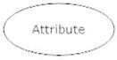

* **Multivalued attribute** can have more than one value. For example, an employee entity can have multiple skill values.



* **Derived attribute** is based on another attribute. For example, an employee's monthly salary is based on the employee's annual salary.

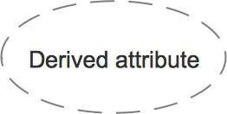

* **Connecting lines**, solid lines that connect attributes to show the relationships of entities in the diagram.



* **Cardinality** specifies how many instances of an entity relate to one instance of another entity. Ordinality is also closely linked to cardinality. While cardinality specifies the occurrences of a relationship, ordinality describes the relationship as either mandatory or optional. In other words, cardinality specifies the maximum number of relationships and ordinality specifies the absolute minimum number of relationships.

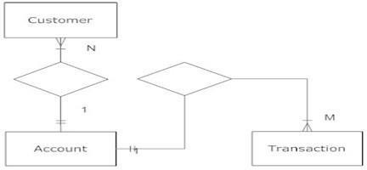

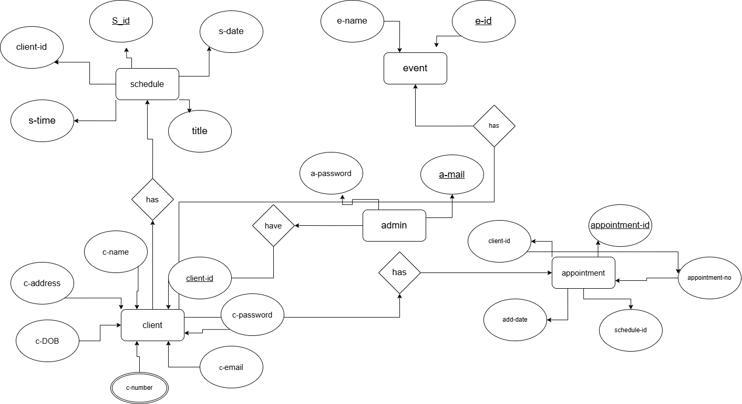

# SYSTEM CONFIGURATION

* 1. **HARDWARE REQUIREMENT**

|  |  |
| --- | --- |
| PROCESSOR | Intel® core i5 CPU 2.11GHZ |
| SYSTEM TYPE | 64-bit |
| RAM | 8 GB |
| HARD DISK | 1 TB |

# SOFTWARE REQUIREMENT:

|  |  |
| --- | --- |
| FRONTEND | HTML,CSS,BootStrap5 |
| BACKEND | PYTHON |
| DATABASE | SQLite |
| OPERATING SYSTEM | WINDOWS |
| DOCUMENTATION | MS WORD |

* 1. **DETAILS OF SOFTWARE**

# OVERVIEW OF FRONT-END

HTML (Hypertext Markup Language) is the core markup language used to create web pages. It’s the backbone of web development, providing the structure for text, images, links, and other elements. Created in the early 1990s, HTML has gone through multiple iterations and updates, evolving to meet the needs of modern websites and applications. Today, HTML5 is the latest standard, adding powerful features like multimedia support, offline capabilities, and APIs for better user experiences.

HTML's simplicity and versatility allow developers to quickly organize content into headers, paragraphs, lists, tables, images, and forms. HTML uses elements and tags—such as <h1>, <p>, <img>, and <a>—to define different types of content. Each HTML element serves a specific purpose, whether to structure text, embed media, or create hyperlinks. These tags create a hierarchical structure, which is essential for accessibility and search engine optimization (SEO), as they allow search engines to understand the page’s content and users with screen readers to navigate it more easily.

HTML’s ability to work in harmony with other technologies like CSS and JavaScript makes it a fundamental building block in web development. In addition to its basic tags, HTML5 introduced semantic elements such as <header>, <footer>, <article>, and <section>, which improve the organization of content and enhance accessibility. HTML5 also allows for embedding multimedia content (like audio and video) directly into a page without needing third-party plugins, making it more versatile for modern multimedia-rich applications.

CSS (Cascading Style Sheets) is a styling language that complements HTML by controlling the visual presentation of web content. CSS was developed to separate content structure from design, giving developers a centralized way to manage the appearance of multiple HTML elements across a site. By defining styles for fonts, colors, layouts, and animations, CSS helps create visually appealing and consistent designs that enhance the user experience.

CSS styles are applied to HTML elements using selectors. These selectors can be element types, classes, or IDs, allowing developers to apply styles precisely to specific parts of the page. CSS properties, such as color, background, font-size, and margin, control the appearance of elements. One of CSS’s key strengths is the ability to cascade, which means styles are applied in a specific order and can override one another. This cascading behavior allows developers to create responsive and adaptive designs that work across different devices.

CSS3, the latest version, introduced many features that have transformed web design, including animations, transitions, and flexible layouts. Features like Flexbox and Grid enable designers to create responsive layouts without needing to write extensive custom code. Flexbox provides a way to arrange elements within a container, while Grid allows for complex two-dimensional layouts. These powerful layout systems are essential for modern, responsive web design, as they allow content to adapt seamlessly to various screen sizes, from desktops to smartphones.

In addition to layout and styling, CSS3 also includes pseudo-classes and pseudo-elements that enable dynamic effects, such as highlighting links when hovered over or styling the first line of a paragraph. These features add interactivity without requiring JavaScript, keeping the page load times fast and enhancing user engagement. CSS’s flexibility and power make it an indispensable tool for creating engaging, accessible, and visually consistent websites.

Bootstrap is a popular open-source framework designed to help developers create responsive, mobile-first websites quickly and efficiently. Originally developed by Twitter, Bootstrap has become one of the most widely used front-end frameworks in web development. The latest version, Bootstrap 5, has made significant improvements by removing dependencies on jQuery, focusing on CSS custom properties, and embracing a more flexible, modular approach.

Bootstrap 5 provides a comprehensive set of components, utilities, and layout options that make it easy to create consistent and attractive designs. At its core, Bootstrap includes a powerful grid system that enables developers to create responsive layouts by defining rows and columns. This 12-column grid system is highly customizable, allowing developers to adjust column widths based on screen size. This responsiveness ensures that content looks great on any device, from desktops to tablets and smartphones.

In addition to its grid system, Bootstrap includes pre-designed components like navigation bars, buttons, cards, forms, and modals. Each component can be styled and customized through Bootstrap’s utility classes, which are predefined CSS classes that offer quick styling options for margins, padding, colors, and typography. These utilities allow developers to fine-tune the appearance of components without writing custom CSS, making it easier to maintain a consistent look and feel throughout the website.

Bootstrap’s component library also includes interactive elements, such as carousels, dropdowns, and tooltips, which are powered by JavaScript. In Bootstrap 5, these JavaScript plugins are modular, meaning developers can include only the components they need, optimizing performance and reducing load times. This modularity is essential for modern web development, where page speed and performance are critical for user retention and SEO.

Five important characteristics make HTML, CSS, and Bootstrap 5

practical nature possible:

* + - Simplicity
    - Efficiency
    - Responsiveness
    - Flexibility
    - Compatibility

# OVERVIEW OF BACK-END

SQLite is a lightweight, serverless, self-contained SQL database engine that is widely supported and often embedded directly within applications. Unlike other relational databases, which require a client-server setup, SQLite operates as a single, portable file, making it an ideal choice for applications requiring minimal configuration, local storage, or lightweight data handling. SQLite is embedded in many popular operating systems, browsers, and mobile applications due to its efficiency and ease of use.

In this article, we’ll explore SQLite's core features, particularly when used with Python, its advantages, and how it differs from traditional relational database management systems (RDBMS) such as MySQL. We’ll also examine SQLite’s functionality, supported features, and provide an example of how to create and interact with SQLite databases using Python.

Python is one of the most versatile and widely used programming languages, and it offers built-in support for SQLite through the sqlite3 module, allowing Python applications to interact with SQLite databases seamlessly. SQLite is especially useful for Python developers working on small- to medium-sized applications, prototyping, testing, or any project where the simplicity of a serverless, self-contained database is an advantage.

SQLite stands out because it does not need a dedicated database server, making it ideal for applications where a standalone database is desired. Data in SQLite is stored directly on disk in a single file, making it easy to deploy, share, and manage without relying on any server setup. While SQLite lacks some advanced features found in larger databases, it’s powerful enough for many use cases, from mobile apps and embedded systems to lightweight web applications and prototyping tools.

SQLite supports many essential SQL operations and advanced features, including data types, indexing, transactions, and built-in full-text search (FTS). Here’s an overview of some key features that make SQLite both functional and reliable:

* **Serverless Operation**: SQLite is a serverless database, meaning it does not require a separate server process. This simplifies setup and eliminates the need for server management.
* **Data Types**: SQLite uses dynamic typing, which allows flexibility in handling data types. While it supports standard SQL types like INTEGER, TEXT, BLOB, REAL, and NUMERIC, it’s not strictly typed, allowing users to store data of any type in any column.
* **Transactions**: SQLite supports ACID (Atomicity, Consistency, Isolation, Durability) transactions, providing reliability by ensuring that database changes are completed entirely or not at all. This is critical for applications that need data integrity, such as finance or inventory management applications.
* **Indexing and Optimization**: SQLite supports indexes, which optimize the retrieval of data and improve query performance. B-tree indexes and table indexing can be created to speed up queries, and primary keys in SQLite tables are automatically indexed, enhancing search efficiency.
* **Full-Text Search (FTS)**: SQLite offers FTS modules that allow for full-text indexing, making it ideal for applications requiring text search capabilities, such as content management systems.
* **Scalability**: While SQLite is designed for smaller datasets, it can handle databases up to 281 terabytes in size, making it suitable for a variety of applications, from small embedded databases to larger datasets in desktop applications.
* **Cross-Platform Compatibility**: SQLite databases are cross-platform, meaning a database created on one operating system can be used on another without compatibility issues. This is particularly beneficial for applications that need to run on multiple devices or operating systems.

# SYSTEM DESIGN

* 1. **ARCHITECTURAL DESIGN**

An architectural model (in software) is a rich and rigorous diagram, created using available standards, in which the primary concern is to illustrate a specific set of tradeoffs inherent in the structure and design of a system or ecosystem.

It is the concept that focuses on the components or elements of a structure or system and unifies them into a coherent and functional whole, according to a particular approach to achieving the objective(s) under the given constraints or limitations. An architecture design is a graphical representation of a set of concepts, that is part of the architecture, including their principles, elements, and components.

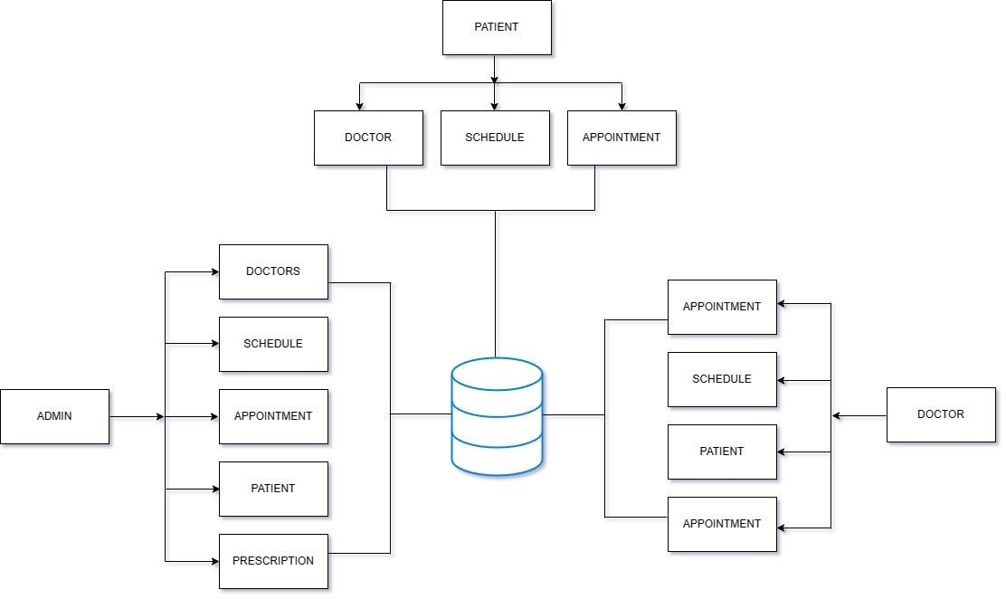

MAIL

RECEIPT

PAYMENT

USER

RECEIPT

CLIENT

# INPUT DESIGN

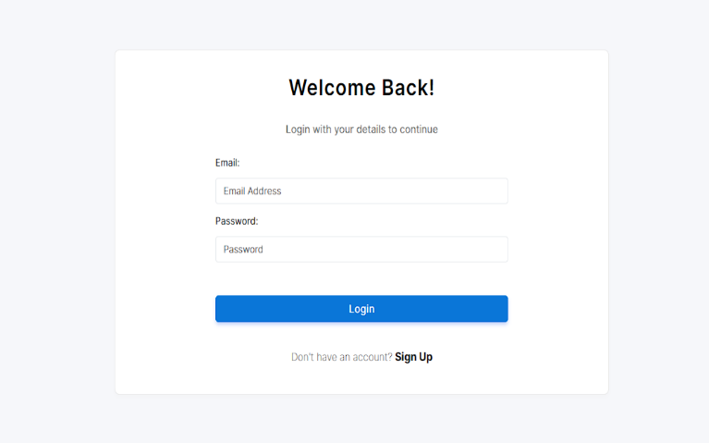

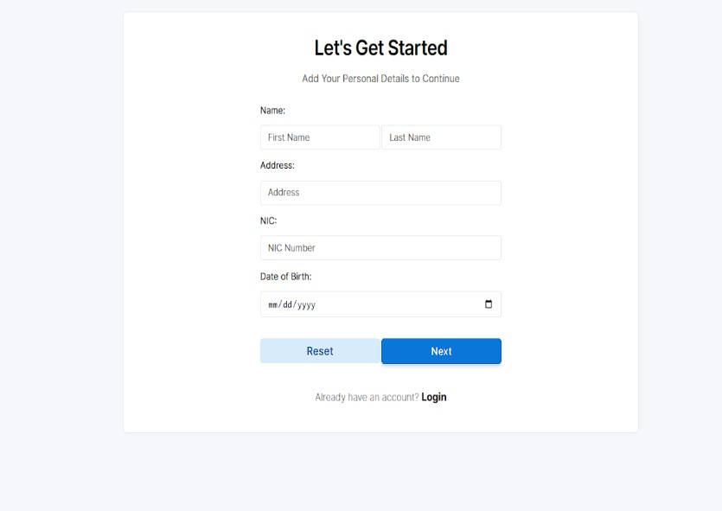

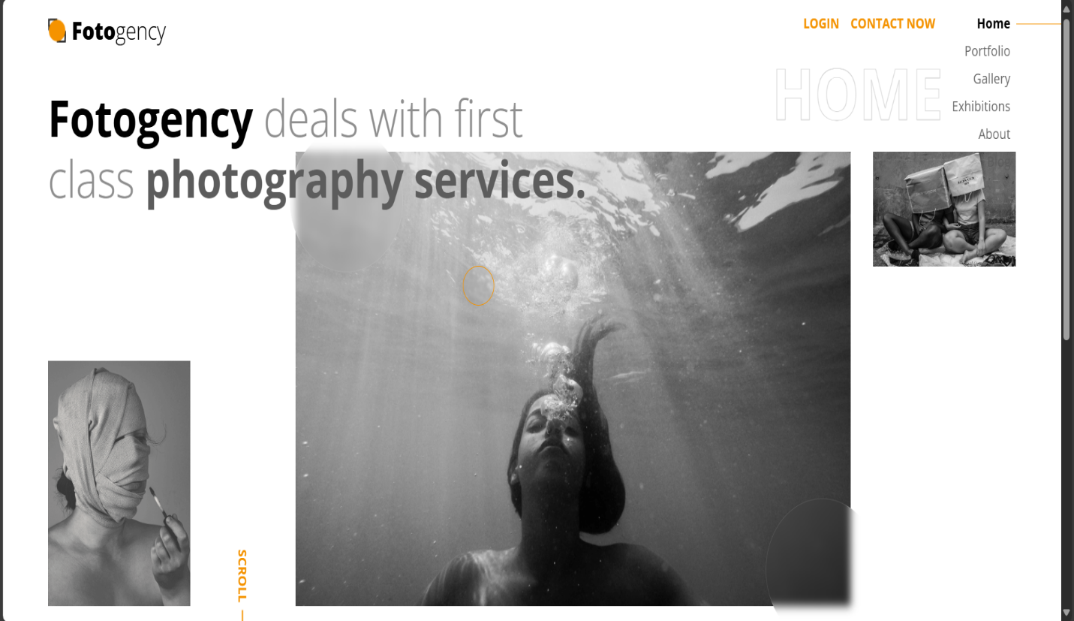

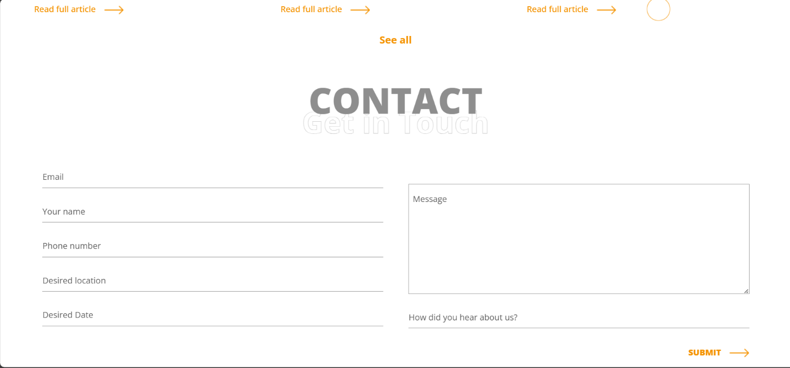

* 1. **OUTPUT DESIGN**

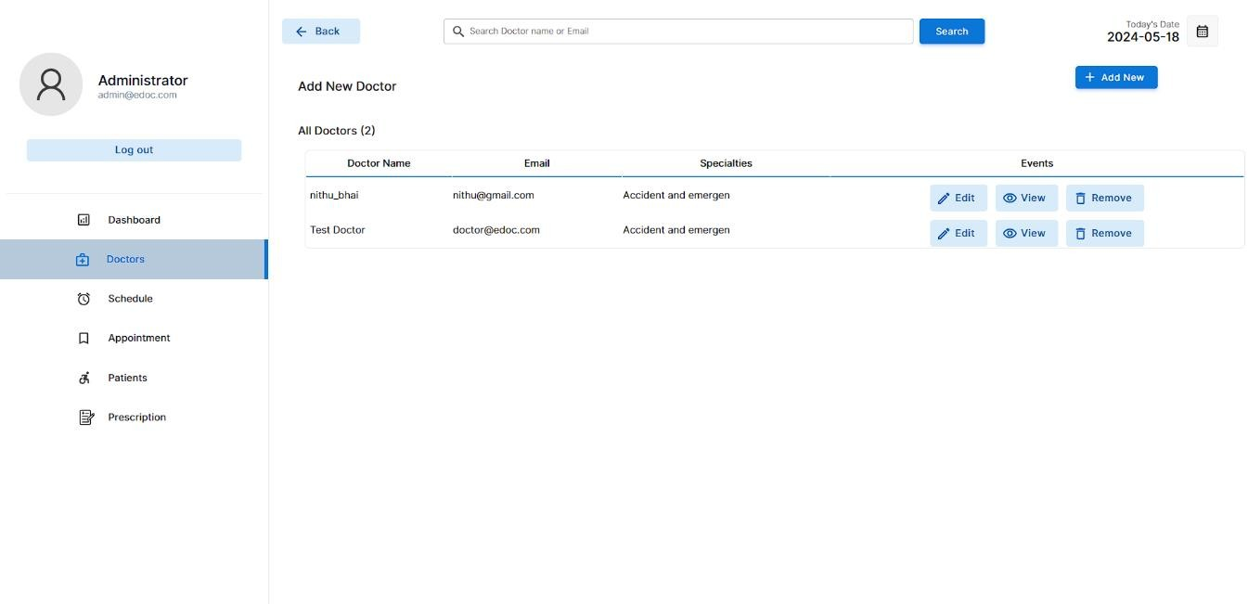

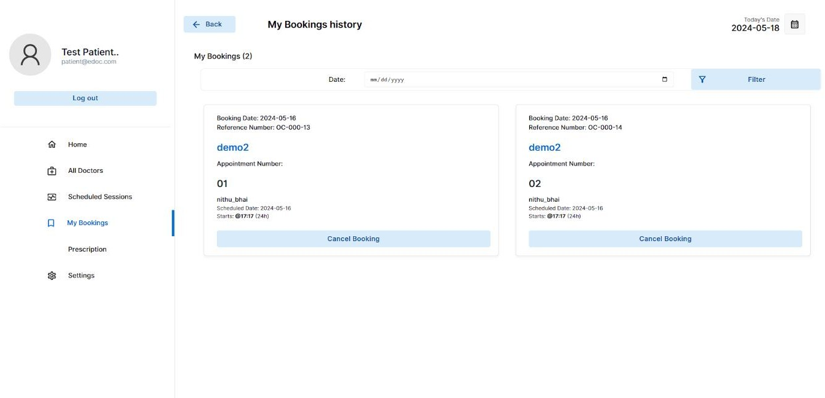



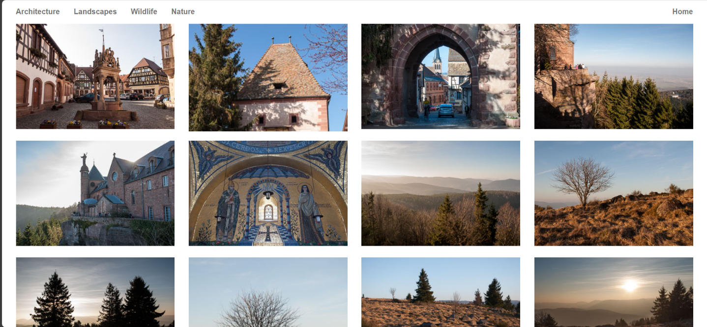

* 1. **SOURCE CODE**

## login.html

<!DOCTYPE html>

<html lang="en">

<head>

    <meta charset="UTF-8">

    <meta name="viewport" content="width=device-width, initial-scale=1.0">

    <title>Login</title>

    <link rel="stylesheet" href="assets/css/style.css"> <!-- Link to the CSS -->

</head>

<body>

    <div class="login-container">

        <h2>Login</h2>

        <form action="/login" method="post">

            <label for="username">Username:</label><br>

            <input type="text" id="username" name="username" required><br>

            <label for="password">Password:</label><br>

            <input type="password" id="password" name="password" required><br>

            <button type="submit">Login</button>

        </form>

        <p>Don't have an account? <a href="#">Sign up</a></p>

    </div>

</body>

</html>

**index.html**

<!DOCTYPE html>

<html lang="en-US" dir="ltr">

  <head>

    <meta charset="utf-8">

    <meta http-equiv="X-UA-Compatible" content="IE=edge">

    <meta name="viewport" content="width=device-width, initial-scale=1">

    <!-- ===============================================-->

    <!--    Document Title-->

    <!-- ===============================================-->

    <title>Fotogency | Photography Agency Template</title>

    <!-- ===============================================-->

    <!--    Favicons-->

    <!-- ===============================================-->

    <link rel="apple-touch-icon" sizes="180x180" href="assets/img/favicons/apple-touch-icon.png">

    <link rel="icon" type="image/png" sizes="32x32" href="assets/img/favicons/favicon-32x32.png">

    <link rel="icon" type="image/png" sizes="16x16" href="assets/img/favicons/favicon-16x16.png">

    <link rel="shortcut icon" type="image/x-icon" href="assets/img/favicons/favicon.ico">

    <link rel="manifest" href="assets/img/favicons/manifest.json">

    <meta name="msapplication-TileImage" content="assets/img/favicons/mstile-150x150.png">

    <meta name="theme-color" content="#ffffff">

<link rel="preconnect" href="https://fonts.gstatic.com">

<link href="https://fonts.googleapis.com/css2?family=Open+Sans:wght@300;400;500;600;700;800&amp;display=swap" rel="stylesheet">

    <link href="vendors/prism/prism.css" rel="stylesheet">

    <link href="vendors/swiper/swiper-bundle.min.css" rel="stylesheet">

    <link href="assets/css/theme.css" rel="stylesheet" />

    <link href="assets/css/user.css" rel="stylesheet" />

  </head>

<main class="main" id="top">

      <div class="cursor-outer d-none d-md-block"></div>

      <nav class="navbar navbar-light py-3 px-0 overflow-hidden">

        <div class="container px-md-5">

          <div class="row w-100 g-0 justify-content-between">

            <div class="col-8">

              <div class="d-inline-block"><a class="navbar-brand pt-0 fs-3 text-black d-flex align-items-center" href="index.html"><img class="img-fluid" src="assets/img/icons/logo-icon.png" alt="" /><span class="fw-bolder ms-2">Foto</span><span class="fw-thin">gency</span></a></div>

            </div>

            <div class="col-4 d-lg-none text-end pe-0">

              <button class="btn p-0 shadow-none text-black fs-2 d-inline-block" data-bs-toggle="offcanvas" data-bs-target="#navbarOffcanvas" aria-controls="navbarOffcanvas" aria-expanded="false" aria-label="Toggle offcanvas navigation"><span class="menu-bar"></span></button>

            </div>

<div class="offcanvas offcanvas-end px-0" id="navbarOffcanvas" aria-labelledby="navbarOffcanvasTitle" aria-hidden="true">

              <div class="offcanvas-header justify-content-end">

                <h5 class="visually-hidden offcanvas-title" id="navbarOffcanvasTitle">Menu</h5>

                <button class="btn p-0 shadow-none text-black fs-2 d-inline text-end" type="button" data-bs-dismiss="offcanvas" aria-label="Close"><span class="menu-close-bar"></span></button>

              </div>

              <div class="offcanvas-body px-0">

                <div class="d-lg-flex flex-center-start gap-3 overflow-hidden">

                  <ul class="navbar-nav ms-auto fs-4 ps-6">

                    <li class="nav-item"><a class="nav-link d-inline-block nav-text-outlined lh-1 text-white fs-5 active" aria-current="page" href="index.html">Home</a></li>

                    <li class="nav-item"><a class="nav-link d-inline-block nav-text-outlined lh-1 text-white fs-5" aria-current="page" href="portfolio.html">Portfolio</a></li>

                    <li class="nav-item"><a class="nav-link d-inline-block nav-text-outlined lh-1 text-white fs-5" aria-current="page" href="gallery.html">Gallery</a></li>

                    <li class="nav-item"><a class="nav-link d-inline-block nav-text-outlined lh-1 text-white fs-5" aria-current="page" href="exhibitions.html">Exhibitions</a></li>

                    <li class="nav-item"><a class="nav-link d-inline-block nav-text-outlined lh-1 text-white fs-5" aria-current="page" href="about.html">About</a></li>

                    <li class="nav-item"><a class="nav-link d-inline-block nav-text-outlined lh-1 text-white fs-5" aria-current="page" href="blog.html">Blog</a></li>

</ul>

                </div>

              </div>

            </div>

            <div class="col-4">

              <div class="d-none d-lg-flex justify-content-end position-relative z-index-1">

                <div class="position-absolute absolute-centered z-index--1">

                  <h1 class="ms-2 fw-bolder text-outlined text-uppercase text-white pe-none display-1">Home</h1>

                </div>

                <div class="d-flex gap-3 align-items-start"><a class="mb-0 ms-auto text-warning fs-0 fw-bold text-uppercase" href="login.html">LOGIN</a>

                  <ul class="navbar-nav navbar-fotogency ms-auto text-end">

                </div>

                <div class="d-flex gap-3 align-items-start"><a class="mb-0 ms-auto text-warning fs-0 fw-bold text-uppercase" href="blog.html#contact">Contact Now</a>

                  <ul class="navbar-nav navbar-fotogency ms-auto text-end">

                    <li class="nav-item px-2 position-relative"><a class="nav-link pt-0 active" aria-current="page" href="index.html">Home</a></li>

                    <li class="nav-item px-2 position-relative"><a class="nav-link pt-0" aria-current="page" href="portfolio.html">Portfolio</a></li>

                    <li class="nav-item px-2 position-relative"><a class="nav-link pt-0" aria-current="page" href="gallery.html">Gallery</a></li>

                    <li class="nav-item px-2 position-relative"><a class="nav-link pt-0" aria-current="page" href="exhibitions.html">Exhibitions</a></li>

                    <li class="nav-item px-2 position-relative"><a class="nav-link pt-0" aria-current="page" href="about.html">About</a></li>

                    <li class="nav-item px-2 position-relative"><a class="nav-link pt-0" aria-current="page" href="blog.html">Blog</a></li>

 </ul>

                </div>

              </div>

            </div>

          </div>

        </div>

      </nav>

<section class="py-4 pt-md-0 pb-8 pb-sm-11 mt-lg-n8">

        <div class="container px-md-5">

          <div class="row">

            <div class="col-md-9 col-lg-7">

              <h1 class="fs-4 fs-md-6 fs-xl-7 mb-5 mb-lg-0 position-relative z-index-2">Fotogency <span class="fw-thin text-300">deals with first class </span><span class="text-400">photography services.</span></h1>

            </div>

          </div>

          <div class="row mt-md-n6">

            <div class="col-2 d-none d-lg-block mt-auto"><img class="img-fluid" src="assets/img/home/img2.png" alt="" /></div>

            <div class="col-1 mt-auto d-none d-lg-block"><a class="scroll-indicator text-warning" href="#footer"> <span>SCROLL </span><img src="assets/img/icons/long-arrow.png" alt="" /></a></div>

            <div class="col-lg-7 position-relative">

              <div class="position-relative overflow-hidden overflow-md-visible"><img class="img-fluid" src="assets/img/home/img1.png" alt="" />

                <div class="img-circle p-5 p-md-7 rounded-circle"></div>

                <div class="img-circle-2 p-5 p-md-7 rounded-circle"></div>

              </div>

<script src="vendors/popper/popper.min.js"></script>

    <script src="vendors/bootstrap/bootstrap.min.js"></script>

    <script src="vendors/anchorjs/anchor.min.js"></script>

    <script src="vendors/is/is.min.js"></script>

    <script src="vendors/fontawesome/all.min.js"></script>

    <script src="vendors/lodash/lodash.min.js"></script>

    <script src="https://polyfill.io/v3/polyfill.min.js?features=window.scroll"></script>

    <script src="vendors/prism/prism.js"></script>

    <script src="vendors/swiper/swiper-bundle.min.js"></script>

    <script src="assets/js/theme.js"></script>

  </body>

</html>

# Index.css

body{

background-image: url(../img/bg01.jpg); background-repeat: no-repeat; background-attachment: fixed; background-size: cover;

height: 100%;

}

html, body { height: 100%;

margin: 0;

}

.full-height {

background: rgba(26, 26, 26, 0.548); background-attachment: fixed;

max-height: 100vh; height: 100vh;

}

table{

width: 100%; padding-top: 5px;

}

.heading-text{ color: white; font-size: 42px;

font-weight: 700; line-height: 63px; margin-top: 15%;

text-align: center; margin-bottom: 0;

}

.sub-text2{

color: rgba(255, 255, 255, 0.5); font-size: 17px;

line-height: 27px; font-weight: 400; text-align: center; margin-top: 0;

}

.register-btn{

background-color: rgba(240, 248, 255, 0.589); color: #345cc4;

}

.edoc-logo{ color: white;

font-weight: bolder; font-size: 20px; padding-left: 20px;

animation: transitionIn-Y-over 0.5s;

}

.edoc-logo-sub{

color: rgba(255, 255, 255, 0.733); font-size: 12px;

}

.nav-item{

color: rgba(255, 255, 255, 0.671); text-align: center;

font-size: 15px; font-weight: 500;

animation: transitionIn-Y-over 0.5s;

}

.nav-item:hover{ color: #f0f0f0;

}

.footer-hashen{ position: absolute; bottom: 0;

left: 45%;

font-size: 13px;

animation: transitionIn-Y-over 0.5s;

}

{

    margin: 0;

    padding: 0;

    box-sizing: border-box;

    font-family: Arial, sans-serif;

body {

    background-color: #f0f0f0;

    height: 100vh;

    display: flex;

    justify-content: center;

    align-items: center;

}

/* Container for the login box */

.login-container {

    background-color: #fff;

    width: 100%;

    max-width: 400px;

    padding: 30px;

    border-radius: 10px;

    box-shadow: 0 4px 8px rgba(0, 0, 0, 0.1);

    text-align: center;

}

.login-container h2 {

    margin-bottom: 20px;

    color: #333;

}

.login-container input {

    width: 100%;

    padding: 10px;

    margin: 8px 0;

    border: 1px solid #ccc;

    border-radius: 5px;

.login-container button {

    width: 100%;

    padding: 10px;

    background-color: #28a745;

    color: white;

    border: none;

    border-radius: 5px;

    cursor: pointer;

    margin-top: 10px;

    transition: background-color 0.3s;

}

.login-container button:hover {

    background-color: #218838;

}

.login-container p {

    margin-top: 10px;

}

.login-container a {

    color: #007bff;

    text-decoration: none;

}

.login-container a:hover {

    text-decoration: underline;

}

@media (max-width: 600px) {

    .login-container {

        padding: 20px;

    }

}

# TESTING

Testing is a fundamental part of web development, helping to ensure that applications run smoothly and meet user expectations. In a web project, testing involves evaluating various aspects of the application, such as functionality, performance, security, and usability, to ensure the application provides a seamless experience. From validating individual functions to simulating end-user behavior, a comprehensive testing strategy enables developers to identify and fix issues early, improving the reliability and quality of the final product. Here’s a breakdown of the different types of testing in web projects, their importance, and best practices to help achieve robust testing.

**1. Unit Testing**

Unit testing is the first layer of testing, focusing on individual functions, methods, or components within the code. Each “unit” is tested independently to ensure it performs its designated task correctly. This is especially useful for validating the smallest parts of the application, such as individual functions or classes.

* **Benefits**: Unit testing helps catch bugs at an early stage, reducing the chances of larger issues down the line. It also makes refactoring and updating code easier, as each component has been tested in isolation.
* **Best Practices**: Write tests as you develop each function or module. Aim for small, isolated tests that cover different scenarios and edge cases.

**2. Integration Testing**

Integration testing examines how different components of the application work together. In a web project, this could mean testing how the frontend and backend communicate, how APIs interact with various services, or how different modules within the application interact.

* **Benefits**: This type of testing helps identify issues in the interaction between modules that may not surface during unit testing. For example, an integration test might reveal issues with API calls, data handling, or how components update in response to data changes.
* **Best Practices**: Start by testing the most critical integrations and expand coverage as the project progresses. Ensure that components are tested under various configurations to simulate real-world scenarios.

**3. Functional Testing**

Functional testing verifies that each feature of the application works according to specifications. It’s especially important for ensuring that user-facing features work as intended, from the login process to form submissions, navigation, and content display.

* **Benefits**: This testing is essential for confirming that the user experience is as expected and that each part of the application performs the actions it should.
* **Best Practices**: Prioritize testing the most frequently used features, ensuring that core functionalities are covered. Test different scenarios, including edge cases, and check that the application behaves correctly under all conditions.

**4. Security Testing**

Security testing assesses the application’s resilience against potential vulnerabilities. This includes checking for common security issues like SQL injection, cross-site scripting (XSS), and cross-site request forgery (CSRF).

* **Benefits**: Security testing protects sensitive user data, ensuring that the application meets security standards and best practices.
* **Best Practices**: Conduct a security assessment early in development, and prioritize testing areas that handle sensitive information, such as login forms, data storage, and payment processing.

1. **User Interface (UI) and User Experience (UX) Testing**

UI and UX testing focus on the visual and interactive elements of the application. UI testing ensures that all buttons, menus, and forms display correctly and are user-friendly, while UX testing looks at how easy and intuitive the application is to use.

* **Benefits:** Good UI/UX testing improves the user experience, making the application more engaging and easier to navigate.
* **Best Practices**: Perform testing on actual devices where possible, or use emulators for consistent results. Engage users in testing sessions to gather direct feedback on the usability and intuitiveness of the application.

**6.Regression Testing**

Regression testing ensures that changes to the codebase, such as new features or bug fixes, don’t break existing functionality. This involves re-running previous tests after updates to make sure the application still performs as expected.

* **Benefits**: Regression testing prevents new bugs from being introduced with each update and helps maintain stability over time.
* **Best Practices**: Automate regression tests for critical functionalities to save time and ensure thorough coverage with each release.

**7.Automated vs. Manual Testing**

Automated testing is essential for repetitive tasks and can speed up the testing process significantly, especially for unit, integration, and regression tests. Manual testing, however, is important for tasks that require a human touch, like UX testing and exploratory testing. A balanced approach, leveraging both automated and manual testing, is often ideal for comprehensive coverage.

|  |  |  |  |  |  |  |  |
| --- | --- | --- | --- | --- | --- | --- | --- |
| **SI No** | **Test Case id** | **Test Description** | **Steps to execute** | **Test data** | **Expected result** | **Actual result** | **status** |
| 1 | 1` | Correct email address and password | Enter the email and password  - Click login | admin admin | Login Successful | Login Successful | Pass |
| 2 | 2 | Wrong email address and password | Enter the email and password  - Click login | Admin shriiya | The Email or Password is incorrect | The Email or Password is incorrect | Pass |
| 3 | 3 | Email address which already registered | -SignUp Enter  all the details  - Click signup | [shri@gmail.com](mailto:shri@gmail.com) | This email address is already being used | This email address is already being used | Pass |
| 4 | 4 | Phone number less than 10 digits | -SignUp Enter  all the details  - Click signup | 897163 | Phone numbers must be at least 10 digits long | Phone numbers must be at least 10 digits long | Pass |
| 5 | 5 | Phone number greater than 10 digits | -SignUp Enter  all the details  - Click signup | 897163529 | Phone numbers must be of a maximum of 10digits long | Phone numbers must be of a maximum of 10 digits long | Pass |
| 6 | 6 | Add  product button | Clicking add product button  on admin form | Button clicked | product  page opened | product  page opened | Pass |
| 7 | 7 | Empty customer name field | Leaving the text field  empty | Leavingthe text field  empty | Enter valid  email address | Enter valid email  address | Pass |

* 1. **IMPLEMENTATION**

The implementation of the PMS started with thorough planning to define the core features and the architecture that would support the system. The team aimed to build a comprehensive solution that would help photography studios manage a range of tasks, including client management, bookings, payment tracking, photo storage, and delivery. The first step was to identify the key stakeholders and their requirements, which included photographers, studio managers, clients, and administrative staff.

The team chose a modular approach to design the system, ensuring that the various functionalities, such as booking management, payment tracking, and image storage, would be independent but easily integrable. The choice of the technology stack was critical, with the team opting for a combination of PHP for the backend and MySQL for the database, with modern front-end frameworks like React for the user interface to enhance responsiveness and interactivity.

The system architecture was designed based on a 3-tier structure, consisting of the presentation layer (front-end), the application layer (business logic), and the data layer (database). This modular approach allowed for better scalability, maintainability, and separation of concerns.

* **Presentation Layer**: The front-end interface was designed to be user-friendly and responsive, ensuring that photographers and clients could easily interact with the system across various devices. The main features included intuitive navigation, image galleries, booking forms, and payment portals. A clean, modern design was adopted to create a professional yet approachable look for the system.

* **Application Layer**: The application layer contained the business logic of the system, including the management of user accounts, photo bookings, payment processing, and report generation. This layer also handled the communication between the front-end and the database, ensuring that all requests were processed securely and efficiently.
* **Data Layer**: The data layer was built on a MySQL database, which was designed to handle the various data entities within the system, such as user information, booking details, photo files, payment records, and client feedback. The database schema was optimized for speed and security, with normalized tables for each major entity to reduce redundancy and ensure data integrity.

User experience (UX) and interface design played a significant role in the success of the Photography Management System. The system was designed to be intuitive, allowing both photographers and clients to interact with it seamlessly, even if they had limited technical expertise. A user-friendly interface reduces the learning curve and increases system adoption, making it a valuable tool for photography businesses.

For photographers and studio managers, the dashboard served as the central hub of the system. From here, users could easily access and manage their bookings, payments, photos, and client information. The dashboard was clean, with quick links to the most commonly used features and real-time notifications about upcoming appointments, new bookings, and pending payments.

For clients, the user interface was designed with simplicity in mind. The booking process was straightforward, allowing them to choose services, photographers, and available time slots in just a few clicks. The photo gallery was visually appealing, with smooth navigation that made it easy to browse through photos from past sessions. The system provided a seamless experience, enabling clients to interact with the photographer or studio manager directly, leave feedback, and even make payments without leaving the platform.

Additionally, the system was designed to be fully responsive, adapting to various screen sizes, including desktops, tablets, and smartphones. This ensured that both photographers and clients could access and use the system anytime, anywhere, even on mobile devices.

A key consideration in the design and implementation of the Photography Management System (PMS) was scalability. Given that photography businesses vary in size and structure, it was essential to create a platform that could grow with the needs of the studio, from small independent photographers to large photography agencies managing multiple photographers and clients.

The system was built with a modular architecture that allowed each feature to be scaled independently. For example, additional photographers could easily be added to the system, with the ability to manage their bookings, payments, and portfolio independently. Similarly, client management and photo storage modules were designed to accommodate a growing volume of data, ensuring that the system could handle increased user traffic, bookings, and photo storage without compromising performance.

As photography businesses expand, the PMS could be adapted to include additional modules or integrate with third-party tools. For instance, new features such as marketing tools for promotional campaigns, integration with social media platforms, or even the addition of advanced AI tools for photo sorting and tagging could be easily incorporated into the system. This flexibility and adaptability made the PMS a long-term solution for photography studios of all sizes.

The Client relationship management (CRM) is crucial for maintaining strong and long-lasting relationships with clients in the photography business. The PMS integrated CRM functionalities to help photographers and studio managers manage and nurture their client base effectively.

The system tracked all interactions with clients, including previous bookings, payment histories, and communication logs. By maintaining a detailed client profile, the PMS helped photographers personalize their interactions with clients, ensuring that they could offer tailored services based on past preferences. The CRM module also provided insights into client behavior, such as frequent bookings or common types of photography services requested, which allowed photographers to predict and cater to client needs more effectively.

Furthermore, the system supported marketing efforts by enabling photographers to send targeted promotions or newsletters to clients. This could include discounts on future sessions, new photography packages, or special offers based on their previous bookings. By automating these processes, the system helped photographers build a loyal customer base while saving valuable time.

The implementation of the Photography Management System was carried out with a focus on improving operational efficiency, enhancing customer satisfaction, and providing photographers and studios with powerful tools to manage their business. By integrating features like client management, booking and scheduling, payment tracking, photo storage, and reporting, the system has streamlined the photography workflow, allowing photographers to focus on what they do best – creating beautiful images. Through careful planning, robust development, and continuous feedback, the PMS is set to revolutionize the way photography businesses operate, ensuring that studios can offer a seamless and professional service to their clients.

# SCREEN SHOTS











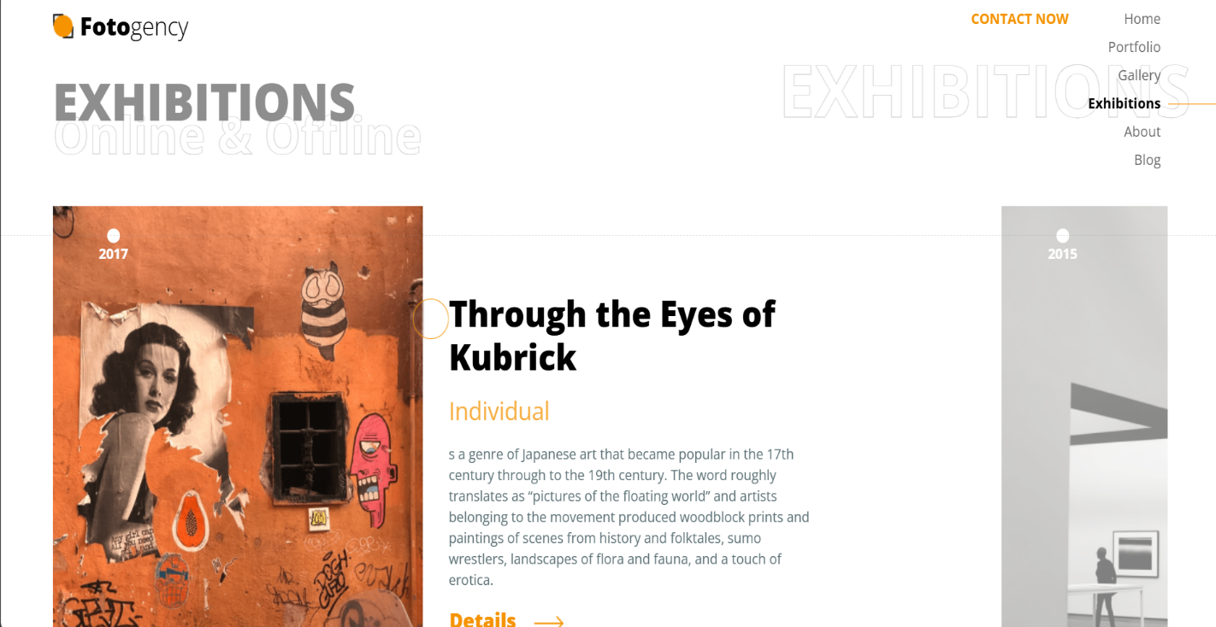

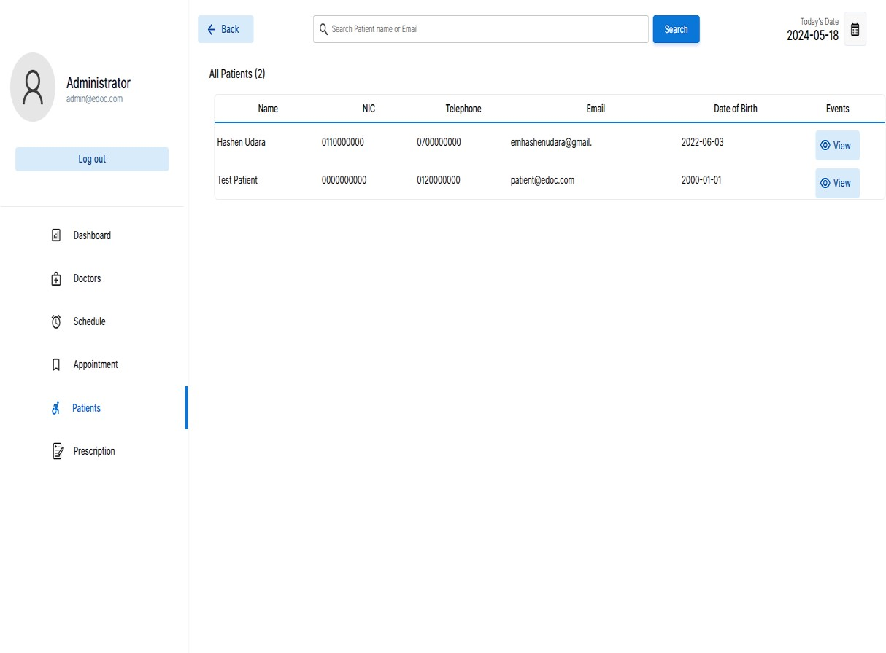

Client

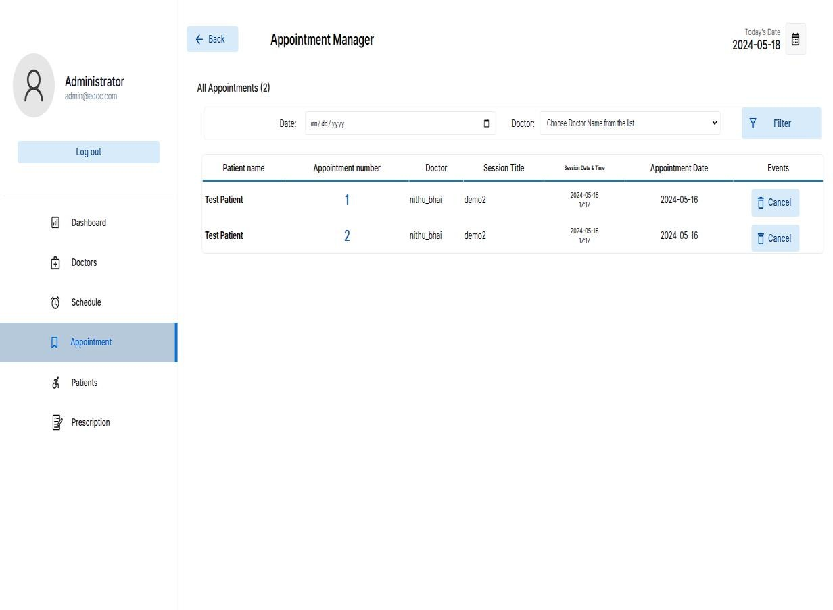

Client

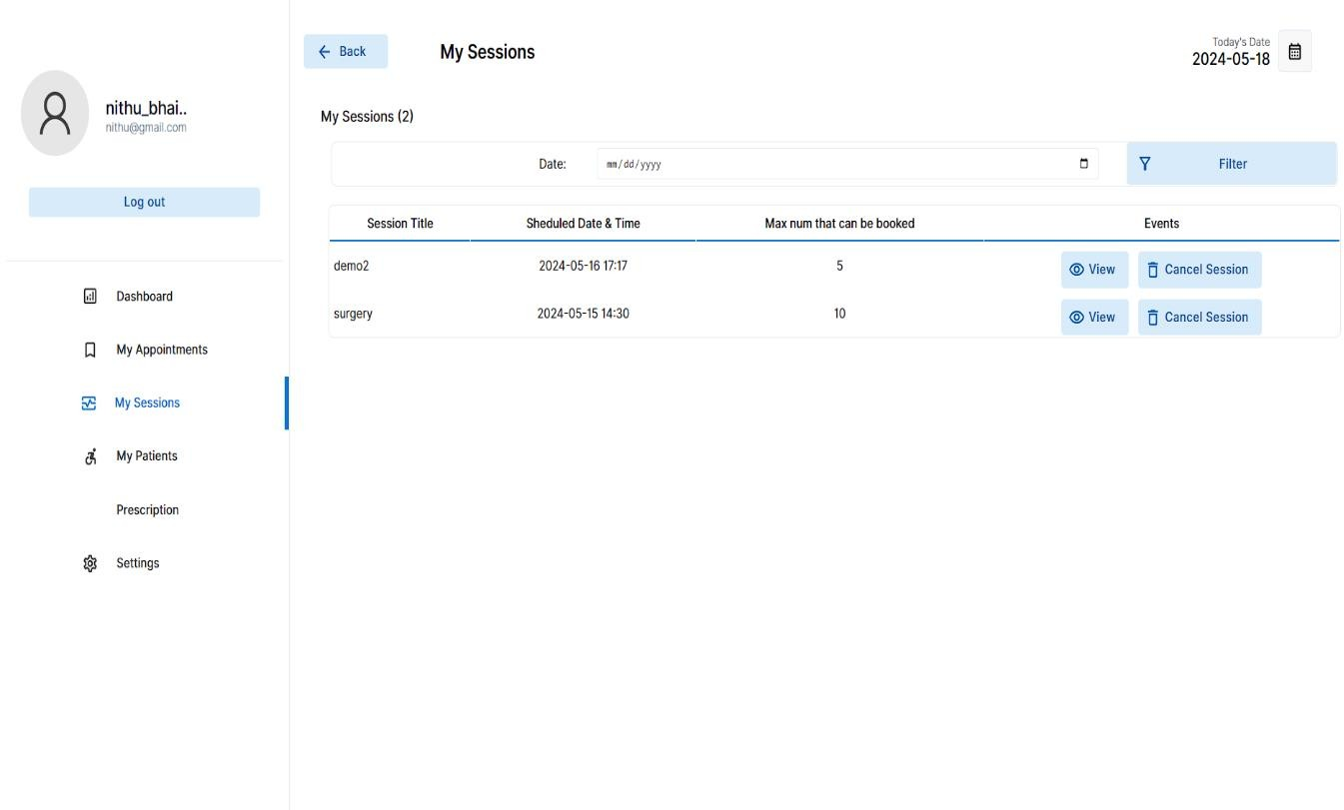

**9. CONCLUSION**

The **Photography Management System (PMS)** serves as an integrated solution for photographers and photography studios, designed to streamline and automate numerous tasks that would otherwise be time-consuming and prone to human error. The system consolidates various aspects of the photography workflow, including client management, booking coordination, payment tracking, photo storage, and delivery, into one unified platform. Through the PMS, photographers can enhance their operational efficiency by automating routine tasks, managing client interactions seamlessly, and ensuring better organization of their assets and services. This not only allows photographers to focus more on their creative pursuits but also improves the overall experience for their clients by ensuring timely communication, easy access to photos, and transparent payment management.

The client management feature of the system allows photographers to maintain detailed profiles for each customer, track communications, manage bookings, and follow up with clients at key moments in the project lifecycle. This fosters better relationships between photographers and their clients, which can translate into increased customer satisfaction, loyalty, and referrals. Furthermore, PMS helps organize bookings, ensuring that photographers never miss appointments or double-book their schedule. The system includes reminders, calendar integration, and automated notifications to keep both photographers and clients on the same page.

Another vital component of the PMS is its ability to handle payments. Through integrated payment tracking and invoicing features, photographers can quickly process client transactions, manage their financial records, and maintain an up-to-date overview of their cash flow. This feature significantly reduces administrative burden and potential errors in manual record-keeping, which can otherwise lead to missed payments or discrepancies.

A significant advantage of a Photography Management System is its ability to securely store and manage large volumes of images. With cloud-based storage solutions, the PMS provides photographers with ample space to store high-resolution images, organize them by project, date, or client, and easily retrieve them when needed. Additionally, automated tools for photo editing, categorization, and filtering, such as machine learning models, can be integrated to streamline the post-production process, helping photographers quickly sort through images based on quality, content, or customer preferences.

The delivery process is also simplified through the PMS, enabling photographers to efficiently share final images with clients. Whether it's through digital galleries, download links, or physical media delivery tracking, clients can access their photos in a seamless manner. This feature ensures photographers maintain high levels of client satisfaction by providing prompt and easy access to the final product.

From a scalability perspective, the Photography Management System is designed to grow with the business. It can be easily adapted to meet the unique needs of different types of photography studios, from small independent photographers to large studios managing a team of photographers and multiple client projects. The PMS can accommodate the addition of new features, like inventory management for photography equipment, advanced scheduling tools, or even integrations with third-party marketing platforms, making it a flexible solution for studios aiming to expand their operations.

The integration of machine learning models to filter photos, such as detecting quality issues, sorting based on client preferences, or identifying faces for group shots, adds a layer of automation that enhances the overall efficiency of the system. By using these models, the PMS can reduce the time spent on manual sorting and image editing, allowing photographers to focus on the artistic and creative aspects of their work. This also helps photographers meet deadlines more effectively, as the system can quickly sift through

large volumes of images, identify the best shots, and present them to the photographer for further editing or final delivery.

Additionally, a Photography Management System can foster collaboration within a studio environment. It provides tools for communication and project management that enable team members to coordinate efficiently. Photographers, assistants, editors, and other staff members can access shared resources, assign tasks, and track progress on different stages of a project, ensuring smooth workflows and enhancing team productivity.

In conclusion, a Photography Management System not only offers a wide range of tools that automate and simplify key business processes, but it also creates opportunities for photographers to elevate their customer experience, enhance their creative workflow, and scale their business operations. By integrating client management, booking systems, payment processing, photo storage, delivery, and even AI-driven editing, a PMS is a comprehensive tool that supports the creative and administrative demands of modern photographers. It is a versatile, scalable, and valuable solution that enables photography businesses to stay competitive, productive, and adaptable in a rapidly changing industry. The result is an overall improvement in business efficiency, customer satisfaction, and the ability to focus on what truly matters—capturing and delivering exceptional photographs.

# Future Enhancements

**1. AI-Powered Image Editing and Enhancement**

In the future, the PMS could integrate even more advanced AI-powered image editing tools. Beyond basic filtering and categorization, AI could be employed to automatically adjust lighting, color balance, and composition based on industry-standard photo aesthetics or client preferences. Additionally, advanced machine learning models could detect and correct imperfections in images, such as skin blemishes or lighting inconsistencies, in a way that mimics professional retouching.

With deep learning, the PMS could even suggest edits based on the type of photography (portrait, landscape, product photography, etc.), reducing the amount of time spent on manual editing and allowing photographers to focus more on creative work.

**2. Enhanced Client Communication and Customization**

Future enhancements could include more sophisticated communication tools that enable real-time collaboration between photographers and clients. Features like live image reviews during shoots, instant feedback, or customized photo proofing platforms where clients can mark and comment on the images they want edited or delivered, would significantly improve the client experience.

Additionally, the PMS could offer more client-specific customization, where the system can learn a client’s preferences over time (e.g., preferred photo styles, edits, album designs) and offer tailored services or packages based on this data. This would create a more personalized experience, improving client retention.

**3. Virtual Reality (VR) and Augmented Reality (AR) Integration**

As technology continues to progress, the use of Virtual Reality (VR) and Augmented Reality (AR) in photography management could be a game-changer. VR could be used for virtual photo shoots or client consultations where clients can experience a virtual photo session or view albums in a more immersive format.

AR could be used to visualize photo compositions, helping clients and photographers experiment with poses, backgrounds, and angles in real-time through their mobile devices or AR glasses. This feature would be especially beneficial for event photographers or studio shoots, where setup and client satisfaction are crucial.

**4. Advanced Analytics and Reporting**

The system could be enhanced to include advanced analytics and reporting tools. These tools could offer insights into the business performance of a photography studio by analyzing booking trends, client preferences, financial data, and marketing efforts. Photographers could gain valuable insights into their most popular services, peak seasons, most loyal clients, and areas where they might improve or grow.

Additionally, PMS could provide predictive analytics, helping photographers anticipate demand, adjust pricing strategies, and better manage their resources. This would support smarter decision-making and improved business outcomes.

**5. Blockchain for Secure Transactions and Image Rights Management**

Future PMS could integrate **blockchain technology** to ensure the security of transactions and the protection of intellectual property. Blockchain could be used to create tamper-proof records of all payments, licenses, and contracts, offering both photographers and clients more transparency and security in their dealings.

For image rights management, blockchain could track the ownership and licensing of images, ensuring that photographers are fairly compensated and that their works are protected from unauthorized use or distribution. This could be especially beneficial for stock photographers or commercial photographers who rely on licensing for revenue.

**6. Mobile App with Augmented Features**

While many PMS platforms currently have mobile app versions, future iterations could bring more robust mobile features that mirror the full desktop experience. Photographers could manage bookings, track payments, share galleries, and edit photos on the go, all from a single mobile app. Additionally, integrating features like geotagging for event locations or live social media sharing could help photographers engage clients in real-time and expand their marketing efforts.

# 10. BIBLIOGRAPHY

**BOOKS**

* Robbins, J. (2018). Learning Web Design: A Beginner's Guide to HTML, CSS, JavaScript, and Web Graphics (5th ed.). O'Reilly Media.
* Lett, J. (2021). Bootstrap 5 Quick Start: Responsive Web Development with HTML, CSS, and JavaScript. Bootstrap Creative.
* Jakobus, B., & Marah, J. (2017). Mastering Bootstrap 4. Packt Publishing.
* Matthes, E. (2019). Python Crash Course (2nd ed.). No Starch Press.
* Sweigart, A. (2020). Automate the Boring Stuff with Python (2nd ed.). No Starch Press.
* Kreibich, J. A. (2010). Using SQLite. O'Reilly Media..

# WEB REFERENCES

* https://developer.mozilla.org/en-US/docs/Learn
* https://www.w3schools.com
* https://getbootstrap.com/
* https://docs.python.org/3
* https://www.sqlitetutorial.net/
* https://sqlite.org/docs.html